Workshop: Quilting Rotational Designs (Jacquie Gering) March 25, 2023 12:00-3:00 pm (Eastern)
Cost: $50 – email RocModPrograms@gmail.com to register
Workshop Description:
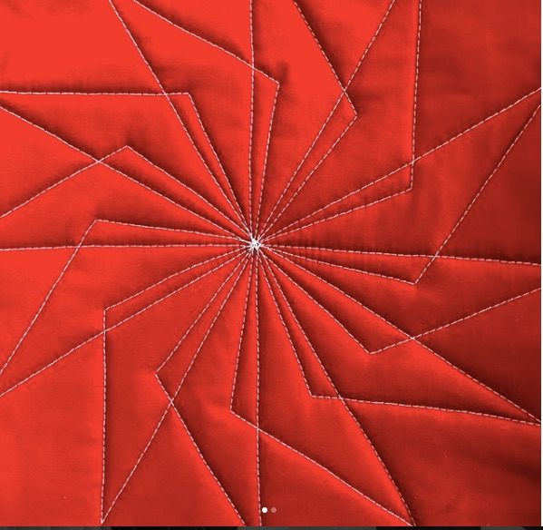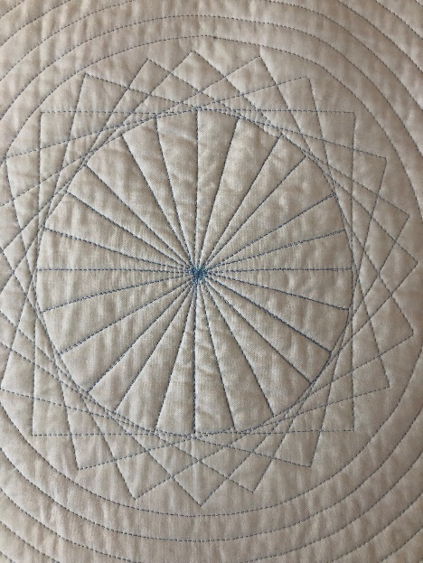
The class focuses on learning to quilt rotational designs with the walking foot. Students will learn how to make templates, mark, quilt and utilize rotational walking foot quilting designs.
The walking foot is typically used for quilting in the ditch and for simple linear designs like grids and echo quilting. While those techniques and designs are staples for the walking foot, that big funny looking foot can do much more. Lines and gentle curves can be combined in a myriad of ways and if you're looking for a challenge, come explore the design potential of rotational designs with the walking foot. Students will learn marking and quilting techniques to quilt these fabulous, complex designs. Students will quilt linear and shape-based rotations and will come away with quilted sample designs along with the technical information and confidence to quilt these designs at home.
About Jacquie Gering:
https://www.jacquiegering.com/about-me
http://tallgrassprairiestudio.blogspot.com/

