Workshop: Designing With Negative Space (Sylvia Schaefer) January 21, 2023, 1-4pm (Eastern)
Cost: $25 - email RocModPrograms@gmail.com to register for the class
Workshop Description:
This non-sewing workshop leads quilters through a number of exercises on designing modern quilts starting from traditional blocks. We’ll get everyone’s creative juices flowing by using colored pencils, scissors, and glue sticks to create fabulous modern quilt designs that incorporate negative space.
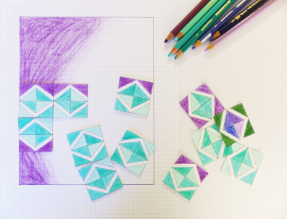
About Sylvia Schaefer: • www.flyingparrotquilts.com •
I’m Sylvia Schaefer, and I have been quilting since 2007. I hold a PhD in marine science, and my background in science often inspires my quilt designs, both directly and indirectly. My quilts and patterns have been published in magazines both online and in print (including McCall’s Quick Quilts, Modern Patchwork, and Machine Quilting Unlimited, and as part of the Modern Quilt Guild’s Quilt of the Month program). My work has been exhibited and won awards regionally and nationally, including ribbons at Pacific International Quilt Festival, the American Quilter’s Society show in Paducah, and MQX, among others. In 2017, I was awarded the second annual Craftsy Quilt Designer Fellowship, allowing me to start my own line of printed patterns sold in quilt shops around the world. I have also appeared on camera in Fresh Quilting and Patchwork Nation. My first book, out in 2019, is a guide to designing modern quilts from traditional blocks, The Quilter’s Negative Space Handbook.

